This Missing Person Alert is intended to advise you of a missing person in your area. If you have information regarding their whereabouts, or think you have seen them, call the issuing law enforcement agency shown below or dial 911. Your identity can remain confidential. | Minnesota Crime Alert Network  MISSING PERSON ALERT
Type of Alert: Original ☐ Posted for Law Enforcement Only ☒ Posted for Public Viewing
Type of Incident: Missing |  |  |  | Date Occurred: 12/20/2017
Incident Location: St. Cloud VACHS, St. Cloud, MN 56303
Details of Incident:

The St. Cloud VA Police Department is seeking assistance in locating DENNIS ANTON JESH, 65 years old. JESH is a veteran and was last seen at the St. Cloud V.A. Hospital campus at approximately 1500 hours on Wednesday, December 20, 2017. He was last seen wearing a black leather jacket and work boots. JESH is non-ambulatory so he is using a yellow powered wheelchair. He is also known to wear paperclips in his nostrils. Medical staff believe JESH may have boarded a city bus to depart the hospital campus but authorities have been unable to locate him and there is concern for his welfare.

If you have seen Dennis JESH or know of his whereabouts, call 9-1-1 or the St. Cloud VA PD at 320-255-6355.

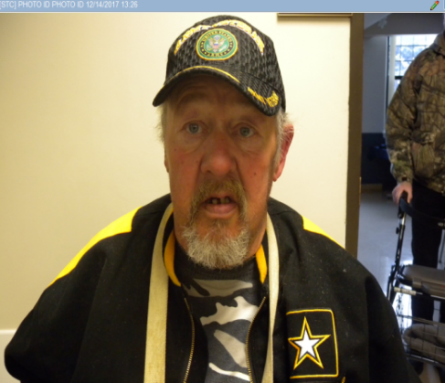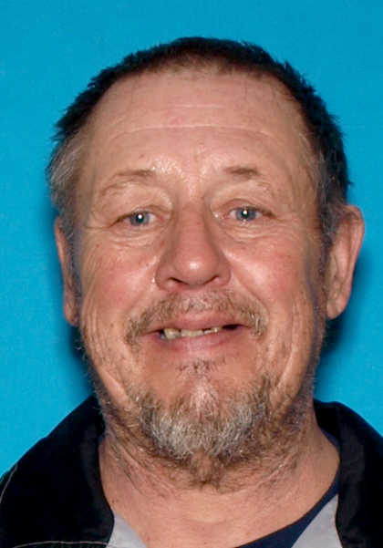
Subject Description:
Sex: male |  | Race: white |  |  |  | Age: 65
Height: 6’0” |  | Weight: 234 |  |  |  | Hair: dark with gray beard | Eye Color:blue
Clothing Description: black leather jack and work boots
Issued By: Click here to enter name |  |  | Agency: St. Cloud VA Police
Phone: 320-255-6355 |  | Fax: |  |  | Email:
Send to list #’s:10,14,16,17,18,19,21,24,27,28,37,39,42,43,44,LE All |  |  |  |  | In Geo Areas:

