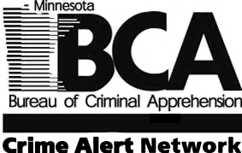  This Missing Person Alert is intended to advise you of a missing person in your area. If you have information regarding their whereabouts, or think you have seen them, call the issuing law enforcement agency shown below or dial 911. Your identity can remain confidential. | Minnesota Crime Alert Network  MISSING PERSON ALERT |  |  |  |  |  |  | 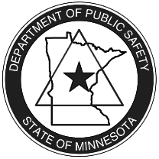
Type of Alert: Original ☐ Posted for Law Enforcement Only ☒ Posted for Public Viewing
Type of Incident: Missing |  |  |  | Date Occurred: 11/11/2017
Incident Location: Onamia, MN
Details of Incident:

The Aitkin County Sheriff’s Office is looking for assistance in locating Alexis Elling, 16, of Onamia. Alexis left her residence on November 11, 2017 and has not returned. In the past, Alexis has left for short periods of time but always stayed in contact with her mother. In this case, no one has heard from her since she left and authorities are concerned for her welfare. Alexis is described as 5’01”, 190 pounds with red hair and hazel eyes. She has tattoos on both arms. If you think you have seen Alexis or know of her whereabouts please contact the Aitkin County Sheriff’s Office at 218-927-7400 or dial 911.

Subject Description:
Sex: female |  | Race: white |  |  |  | Age: 16
Height: 5’01” |  | Weight: 190 |  |  |  | Hair: red/auburn | Eye Color: hazel
Clothing Description:
Issued By: Heidi Lenk |  |  | Agency: Aitkin County Sheriff’s Office
Phone:218-927-7400 |  | Fax: |  |  | Email:
Send to list #’s: 10,17,18,19,21,27,38,42,43, LE statewide |  |  |  |  | In Geo Areas:

