Minnesota Crime Alert Network
This Crime Alert is intended to advise you of criminal activity that may affect you or your business. If you have questions or suspect information, call the issuing law enforcement agency shown below. Your identity can remain confidential.

Type of Alert: Original ☐ Posted for Law Enforcement Only ☒ Posted for Public Viewing
Type of Incident: Missing Person/Welfare Check |  |  |  |  |  | Date Occurred: 12/20/2017
Incident Location: 516 Delaware Street SE, Minneapolis, MN 55455
Details of Incident:

The University of Minnesota Police Department is seeking the public’s assistance to locate, Ramona Lynn MARTIN, 59 years old. Ramona MARTIN is a vulnerable adult and was separated from her family while visiting a patient at M-Health Hospital on 12/20/2017. Follow-up investigation revealed that MARTIN has Alzheimer’s and is in a wheelchair. MARTIN told a family member she wanted to visit Haskell’s Liquor Downtown Minneapolis (81 South 9th Street) before they close this evening. Metro Transit Police located video footage of the subject last seen boarding a westbound Green Line Train on the East Bank LRT Station.

If you have seen Ramona MARTIN or know of her whereabouts, call 9-1-1 or the U of M PD at 612-624-7828.

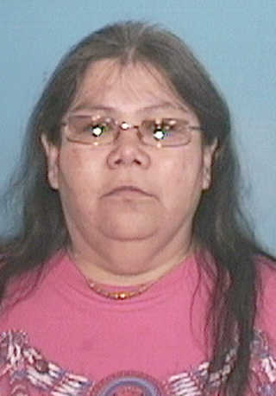
Subject Description: Ramona Lynn Martin, DOB: 5/13/1958

Sex: F |  |  | Race: |  |  |  |  | Age: 59
Height: 4’ 11’’ |  |  | Weight:180 |  |  |  |  | Hair: blk |  | Eye Color: brown
Clothing Description: STOCKING CAP BLK JACKET JEANS GREEN SCARF AND BOOTS
Vehicle Information:
Year: | Make: |  |  | Model: |  |  |  |  | Color: |  | Plate #:
Issued By: Sgt Panek |  |  |  |  | Agency: U of M Police Department
Phone: 612-624-7828 |  |  | Fax: |  |  |  | Email:
Send to list #’s: |  |  |  |  |  |  | In Geo Areas: REgion G

